**NetSim - MATLAB Interfacing for UAV/Drone/Flying Ad hoc network simulations**

**Software Recommended:** NetSim Standard v13.3 (64-bit), Visual Studio 2022, MATLAB 2020b or higher. MATLAB, Simulink, Robotics and System Toolbox

**Project Download Link:**

Follow the instructions specified in the following link to download and set up the Project in NetSim:

<https://support.tetcos.com/en/support/solutions/articles/14000128666-downloading-and-setting-up-netsim-file-exchange-projects>

# **Objective**

In this project, we are going to explain how users can simulate UAV devices in NetSim by interfacing with MATLAB's Simulink.

# **2D View in NetSim and 3D View in MATLAB:**

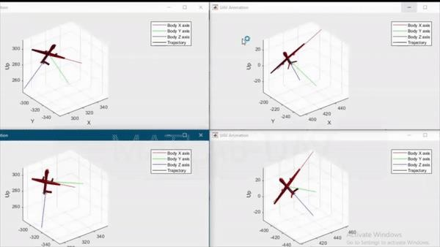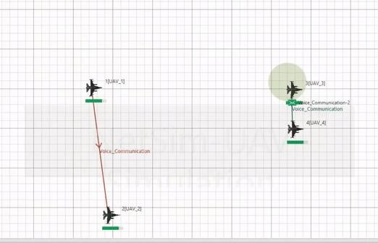

**2D- Animation in NetSim** **3D Animation in MATLAB**

# **NetSim - Simulink Interfacing**

Upon interfacing NetSim with MATLAB the following tasks are performed during the simulation start:

* MATLAB Engine process is initialized
* SIMULINK Model is loaded

Upon simulating a network created in NetSim the following tasks are performed periodically:

* SIMULINK Model is simulated
* SIMULINK Model is paused
* NetSim reads the data generated by SIMULINK from the MATLAB workspace
* Updates the coordinates of the devices.
* During the Simulation, the SIMULINK Model is started and paused several times for NetSim and SIMULINK simulations to run synchronously. The X, Y, and Z coordinates obtained from SIMULINK are read from the MATLAB workspace and given as input to NetSim's Mobility model. In this example, coordinates are taken every one second and updated to the device mobility.

# **Output/Metrics specific to this example**

* NetSim Animation- Mobility of the devices configured in NetSim is given as input from MATLAB

**Sections of source code modified:**

* Mobility.c
  + fn_NetSim_Mobility_Init(): call to init_uav() function
  + fn_NetSim_Mobility_Run(): Call to uav_run() function
  + fn_NetSim_Mobility_Finish(): Call to finish_uav() function
* Mobility.h
* UAVBasedMobility.c
  + init_uav(): Initializes MATLAB, Loads SIMULINK Model, starts and pauses SIMULINK simulation , and initializes the UAV devices in MATLAB to start simulation along with NetSim's simulation.
  + uav_run(): Starts NetSim and MATLAB simulation simultaneously and gets the co-ordinates from MATLAB workspace for every step size set in NetSim.
  + uavcorr(): Function to get co-ordinates from MATLAB.

# **Running the NetSim scenario with UAV Based Mobility**

* Before opening the Example make sure that you have replaced the XML file in the NetSim Installation directory mentioned below and then Open the Example saved in the workspace.
* Copy **GeneralProperties.xml** file to <NetSim Installation Directory>\ Docs\xml\Properties. And copy **Configuration.xsd** to <Netsim Installation Directory>\Bin path>bin 64.
* Make sure that all devices are UAV Mobility enabled in General properties.

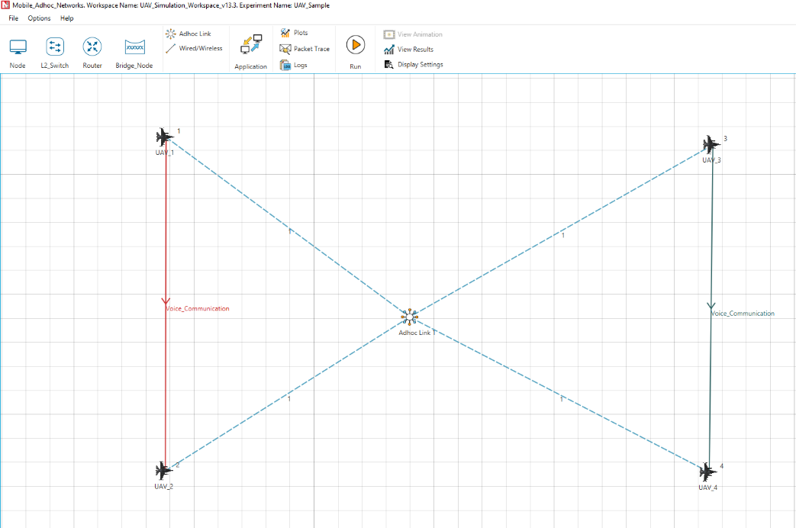

Figure 1:Network setup for UAV matlab simulation

# **Steps:**

# 1.Open Control panel >system>Advanced system settings>Edit the system environment variable>Environment variables

2.Make sure that the following directory is in the PATH (Environment variable)

<MATLAB_INSTALL_DIRECTORY>\bin\win64

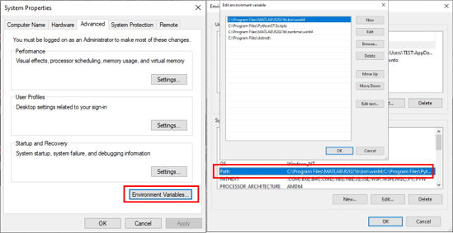

Figure 2: Environment path variables.

**Note**: If the machine has more than one MATLAB installed, the directory for the target platform must be ahead of any other MATLAB directory (for instance, when compiling a 64-bit application, the directory in the MATLAB 64-bit installation must be the first one on the PATH).

1. Open the Source codes in Visual Studio by going to Your work-> Workspace and Clicking on the Open code.
2. Under the Mobility project in the solution explorer, you will see that and UAV_Basedmobility.c files which contain source codes related to interactions with MATLAB.
3. Open the Netsim.The **UAV_Simulation_Workspace** comes with a sample configuration that is already saved. To open this example, go to Your Work option in the Home Screen of NetSim and click on the UAV_Simulation_Example under the experiments list.
4. Run the simulation with Play and record animation to have both Animations simultaneous.

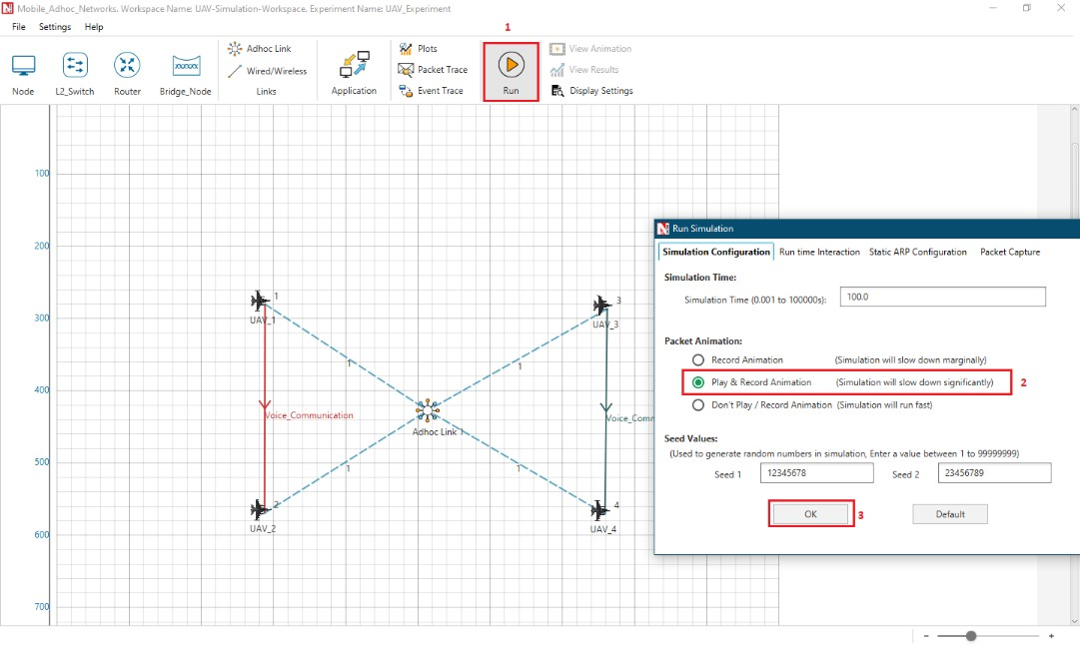

Figure 3:Scenario setup for UAV Matlab simulation interfacing

1. It will open the MatlabInterface.exe console window. You will observe that as the simulation starts in NetSim, MATLAB gets initialized and UAV Animation for all the devices in NetSim gets initialized as the simulation runs there will be continuous interaction between NetSim and MATLAB where the X, Y, and Z co-ordinates will be updated in NetSim from MATLAB.

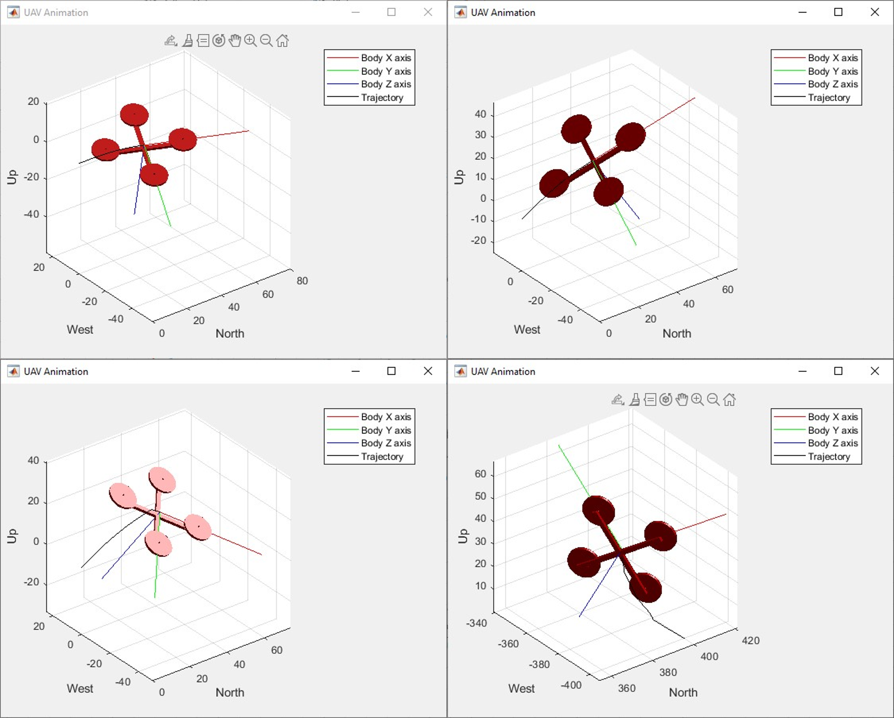

Figure 4: Drone in MATLAB

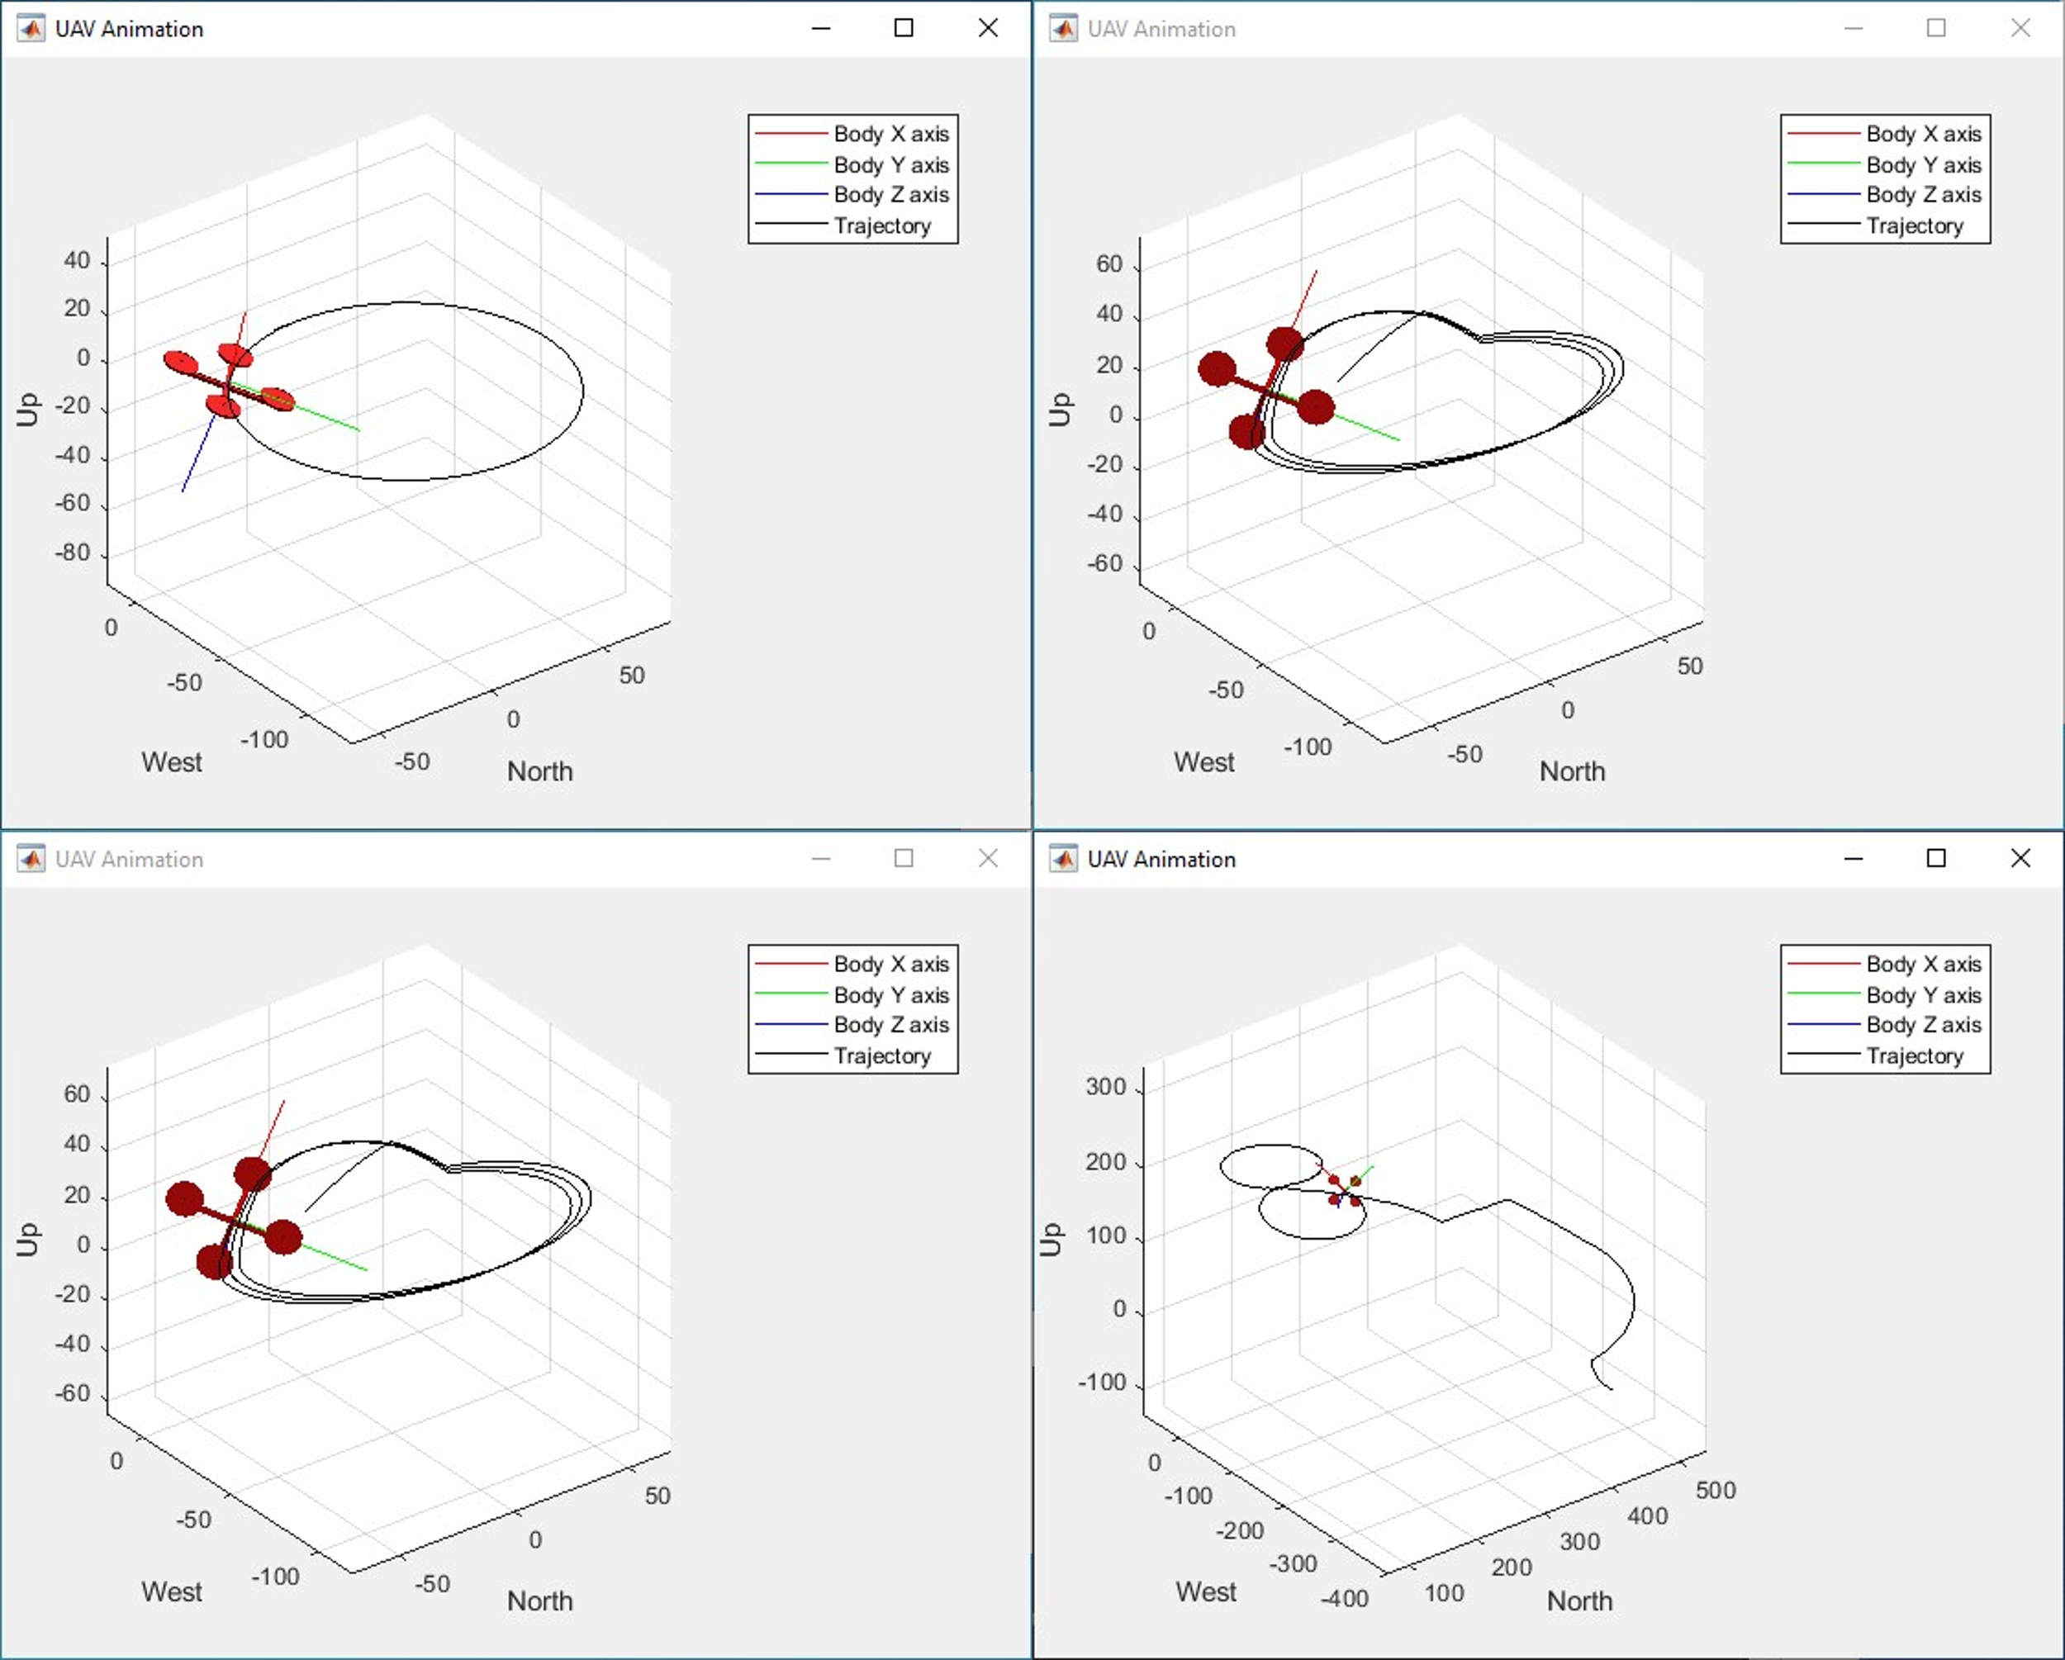

Figure 5: MATLAB Flight Path